Why Mint Your Miniature Bottles as NFTs?

1. What is Minting?
Minting in the digital world refers to creating a unique digital asset on the blockchain. When you mint a miniature bottle as an NFT (Non-Fungible Token), you're turning it into a digital collectible with unique metadata. This NFT verifies ownership and provenance, ensuring that it’s authentic and connected to you.
- NFTs are like digital certificates of authenticity and ownership that exist on the blockchain.
- Each NFT has a unique ID and metadata that cannot be replicated, which makes each one unique to the owner.

2. Why Mint Your Miniature Bottles?
- Preservation of Rarity: Some miniature bottles are rare, and by minting them, you preserve their uniqueness and give collectors a way to verify their rarity.
- Proof of Ownership: Minting your bottles as NFTs provides clear proof of ownership. Each token has an unchangeable record on the blockchain, so buyers or collectors can verify its authenticity.
- Transferable Value: NFTs allow you to trade or sell your collection digitally. You can transfer ownership of your miniature bottle NFTs while maintaining the original value and rarity.
- New Market Opportunities: By minting, you open your collection to a digital market, reaching more collectors and enthusiasts who are interested in digital collectibles.

3. How Blockchain Works with Your Minted NFTs
- Decentralized Verification: Blockchain is a decentralized ledger that keeps a secure record of all transactions. When you mint a miniature bottle NFT, the blockchain verifies and logs the transaction, making it impossible to alter.
- Transparent and Permanent Record: Each transaction (minting, buying, selling) is stored on the blockchain, allowing anyone to see the history of ownership. This transparency builds trust and adds value to your collection.
- Smart Contracts: NFTs often use smart contracts to manage transactions. Smart contracts are self-executing contracts with terms written directly into code, ensuring that the ownership transfer is seamless and secure.

Summary:
Minting your miniature bottles on the blockchain provides an innovative way to protect, share, and even sell your collection in the digital world. It leverages the transparency, security, and permanence of blockchain technology to ensure that each digital representation of your collectible is unique, valuable, and traceable.
Certainly! Here are some key reasons why minting your miniature bottles as NFTs offers benefits in terms of security, safety, and ease of access:

Top Reasons to Mint Your Miniature Bottles as NFTs

1. Enhanced Security
- Protection Against Counterfeits: Minting creates a unique digital token for each bottle that includes immutable metadata, making it easy to verify authenticity. Blockchain technology helps prevent counterfeit copies since the originality and ownership are recorded and verified digitally.
- Permanent Ownership Record: NFTs store a permanent record of ownership on the blockchain, making it secure and tamper-proof. This digital certificate is far more secure than traditional ownership proofs (like receipts or certificates) that can be lost, forged, or damaged.

2. Safety for Valuable Collections
- Digital Preservation: By minting, you create a lasting digital version of your collection, reducing the risk of physical damage, theft, or deterioration. Even if the physical bottle is lost or broken, the digital token maintains the value and record.
- Stored in a Digital Wallet: NFTs are stored securely in a digital wallet, providing a safe, easily accessible space for collectors and owners. Only the wallet owner can access and manage these NFTs, ensuring the safety of your investment.

3. Easy to Showcase and Share
- Global Showcase: Unlike physical collections, NFTs can be displayed on online marketplaces, personal websites, or social media platforms, making it easy to showcase your collection to a global audience. Digital collectors and enthusiasts can view and appreciate your items without requiring you to ship them.
- Instant Ownership Transfer: NFTs allow seamless transfers of ownership. Whether you're gifting, trading, or selling, blockchain makes transferring the NFT secure and instant, with all transaction details permanently recorded.

4. Convenient Record-Keeping
- Transparent Provenance: NFTs record each item's history, making it easy to trace its origin and ownership. This transparency adds credibility, allowing potential buyers or enthusiasts to verify the item's background, rarity, and authenticity.
- Smart Contracts for Secure Transactions: Each NFT can be encoded with a smart contract, allowing for automatic terms of ownership and resale royalties. This way, as an original owner, you can even earn a small percentage each time your NFT is resold, keeping a record of its journey in the market.

Summary:
Minting your miniature bottles as NFTs offers powerful advantages. You can keep your collection safe, secure, and easily shareable, with every detail logged and verified on the blockchain. It not only provides a protective layer against counterfeits but also simplifies ownership transfers, making your collection accessible to a worldwide audience while ensuring that your items' history, rarity, and value are preserved permanently.

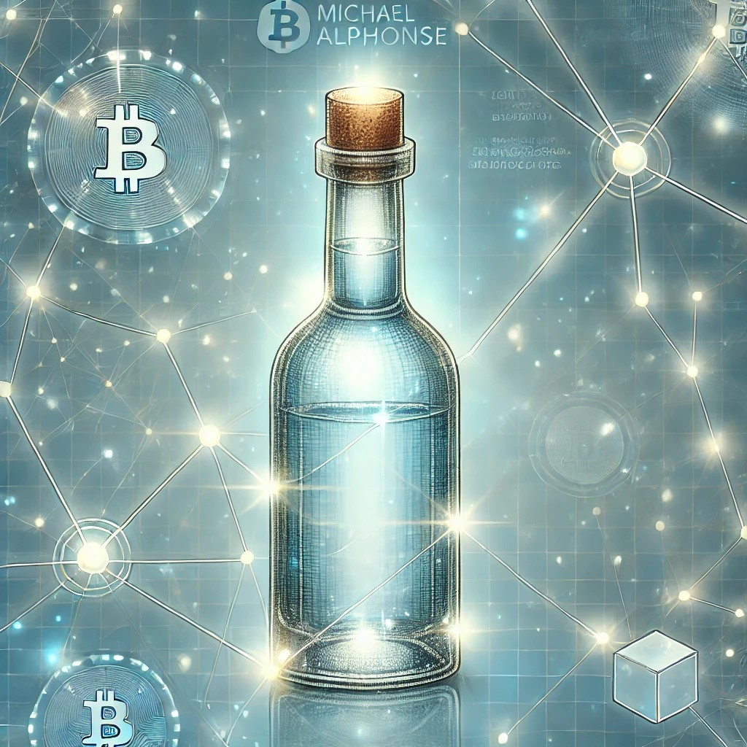

More Benefits of Minting Your Miniatures as NFTs

5. Increased Value Through Digital Rarity
- Limited Editions and Rarity: Just like physical collectibles, you can limit the number of minted NFTs for your miniatures, making them exclusive and enhancing their value. Limited editions are highly appealing to collectors, as digital scarcity can often increase demand and value over time.
- Proof of Ownership: By minting, you ensure each miniature bottle has a unique identifier, demonstrating it’s one-of-a-kind or part of a rare series. This adds intrinsic value, especially in the eyes of collectors who value exclusivity.

6. Blockchain Technology: Transparent and Trustworthy
- Immutable Records: Blockchain technology provides a secure, unchangeable record of transactions. This means every interaction with your NFT—whether it’s a transfer, sale, or display—leaves a clear, permanent digital footprint. This transparency fosters trust, as buyers and collectors can see the entire history of an NFT.
- Decentralized Authentication: Because blockchain is decentralized, no central authority controls it, ensuring your NFT's authenticity isn’t dependent on a single party. This reduces the risk of manipulation and adds credibility, making it easier for potential buyers or admirers to trust its origin.

7. Unlockable Content for Added Value
- Hidden Perks: NFTs can include “unlockable content,” offering exclusive extras like high-resolution images, behind-the-scenes details, or even access to special events or discounts. For example, collectors could receive a link to a personal viewing of your collection or gain access to virtual or in-person meetups with other enthusiasts.
- Digital Enhancements: Your NFT can contain additional details, such as history, stories, or trivia about each bottle. These add-ons offer more than just a digital token; they enhance the collector’s experience with a personalized touch.

8. Community Building and Networking
- Building a Fanbase: Minting can help you grow a community of fellow collectors who share an interest in miniatures, sparking discussions, events, and even collaborations. Many NFT owners build strong communities around shared interests, adding value to the collection and networking opportunities for the creator.
- Engagement Opportunities: Once minted, your NFTs can connect you with like-minded enthusiasts or even prospective buyers worldwide. Hosting virtual tours or live events becomes easier, and these events can increase both visibility and demand for your collection.

9. Royalties for Long-Term Profit
- Automatic Royalties: As the original creator, you can set a royalty percentage on your NFTs, ensuring you earn each time your miniature NFTs are resold. These royalties are encoded within the NFT itself and automatically executed through smart contracts, creating a passive income stream.
- Growing Value Over Time: With automatic royalties, you benefit from the growing value of your NFTs, especially if your collection becomes more valuable over time. Every future transaction supports your continued investment, a benefit that’s hard to replicate with physical items alone.

10. Future-Proofing Your Collection
- Adaptable to New Technology: NFTs are at the forefront of digital ownership. As technology evolves, having your collection in digital form means it can be easily integrated into new platforms, virtual spaces, or augmented reality experiences. Future advancements in technology can bring added functionality, keeping your collection relevant.
- Interoperability Across Platforms: Once minted, your NFTs can be showcased across multiple digital platforms, marketplaces, and even metaverse spaces. This adaptability means your collection can reach a much broader audience, positioning it well in the growing digital landscape.

In Summary:
Minting your miniatures as NFTs provides more than just digital representation; it adds layers of value, security, and connectivity. Blockchain technology secures your collection, gives you the flexibility to reach a global audience, and allows future-proofed functionality. From exclusive perks to royalties, minting can transform your collection into a dynamic, engaging, and revenue-generating asset.

If you need any further information or assistance, please don't hesitate to reach out.
You can contact me at email me

