Miniature Spirits: A Collector's Guide to Tiny Bottles of History

Introduction
Miniature alcohol bottles, often referred to as "miniatures," "nips," or "airline bottles," are fascinating collectibles that blend art, history, and craftsmanship. These small bottles hold more than just a shot of alcohol—they contain stories of innovation, marketing genius, and cultural history. In this book, we will dive into how miniature bottles began, their role throughout the years, and why they have become such desirable artifacts among collectors.

Chapter 1: The Birth of the Miniature Bottle
The concept of miniature alcohol bottles dates back to the late 19th century. Notable early adopters included brands like Dewar's and Hiram Walker, which produced miniatures to promote their whiskies. These early miniature bottles became popular as marketing tools, giving potential customers a chance to sample the product without committing to a full-sized purchase.
In the early 20th century, as international travel and hotel stays became more common, miniatures gained popularity for their convenience. They became a way for travelers to enjoy a small amount of their favorite spirit without carrying large, cumbersome bottles. Over time, their size also made them a staple in first-class train cabins and cruise liners, and eventually, they became synonymous with air travel.

Chapter 2: The Evolution of Miniature Bottles
As time went on, miniatures began to serve more than just a practical purpose—they became a way for brands to show off their creativity and establish their identity. The designs of these bottles became more ornate and elaborate, with unique shapes, labels, and even handcrafted stoppers. Companies like Johnnie Walker, Jack Daniel's, and Glenfiddich put considerable effort into designing miniatures that reflected the character of their full-sized counterparts. Including unique elements like intricate bottle designs, embossed glass, and vibrant label artwork, these bottles were often miniature replicas of their larger counterparts, which made them highly collectible.
Images or descriptions of some of these unique designs would help illustrate the evolution over time. For example, early Johnnie Walker miniatures often featured distinctive square bottles with slanted labels, while Glenfiddich produced elaborate glass shapes that mirrored their larger offerings. These visual elements helped establish a brand identity and showcased the creativity involved in producing miniatures.
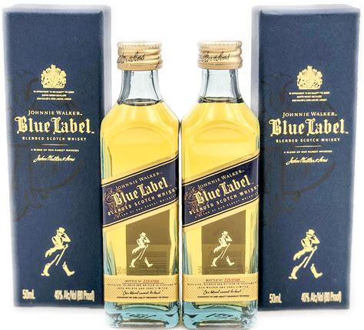

Chapter 3: The Collecting Craze
Collecting miniature bottles gained momentum in the mid-20th century. Enthusiasts began to recognize the value of these miniatures as more than simple containers of alcohol—they were miniature works of art. The bottles were often beautifully designed, with vibrant labels and intricate details. Clubs for collectors started to form, such as the Mini Bottle Club in the UK, which helped connect people with similar passions and provided platforms to buy, sell, and trade. Another valuable resource is the website [Miniature Treasures]( https://www.miniaturetreasures.co.uk ), which offers a curated selection of miniature bottles for collectors, catering to both novices and experienced enthusiasts.
One famous collector, Bill Butler, amassed over 50,000 miniature bottles from around the world, showcasing the dedication and passion that many enthusiasts have for these tiny treasures. Another notable collection belonged to Olga Sinclair, whose collection focused on rare whiskey miniatures, many of which were displayed in themed cabinets that highlighted their unique history and origins.
The diversity of bottles ranges from common brands to highly limited-edition releases that were often produced for special occasions like royal events, anniversaries, or holidays. For example, Johnnie Walker produced a limited-edition miniature set to commemorate Queen Elizabeth II's Diamond Jubilee, and Macallan released a special collection of miniatures to celebrate their anniversary. Each of these releases comes with a rich backstory, adding significant value and allure to collectors.
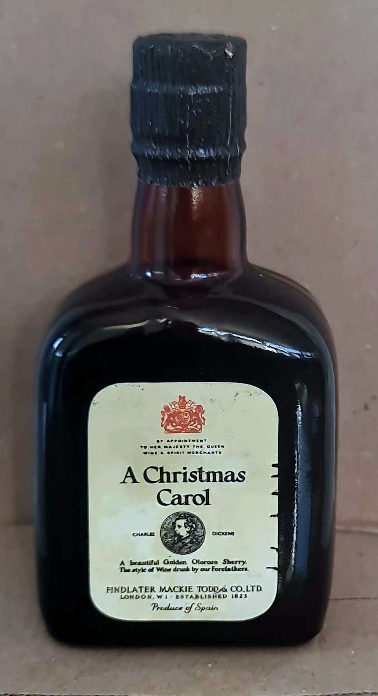

Chapter 4: The Rarest Miniatures
The world of miniature alcohol bottles contains some incredibly rare and valuable items. Some of the rarest include bottles produced during the Prohibition era or those made by defunct distilleries. Miniatures from old, closed distilleries like Port Ellen or Brora in Scotland are considered extremely valuable, given that no new production will ever occur.
Another notable example is a miniature of the Macallan 1926. While the full-sized bottles from this vintage are often cited as the most expensive whiskey in the world, the miniatures also command impressive prices due to their scarcity and historic nature. There are also unique miniatures that were crafted as gifts for dignitaries or used for promotional purposes during brand launches.
Anecdotes about specific auctions add to the allure of these rare miniatures. For example, a miniature of the Macallan 1926 was sold at a Bonhams auction for a record price, highlighting the immense value that collectors place on these tiny treasures. Additionally, notable collectors like Richard Gooding, who amassed one of the largest private whiskey collections in the world, have been known to acquire rare miniatures, further increasing their desirability and status within the collecting community.

Chapter 5: How to Identify Authentic and Valuable Miniatures
Identifying valuable miniature alcohol bottles requires a keen eye. Authenticity often involves checking for intact seals, accurate labeling, and original packaging. Limited edition releases usually have some indication of a production number or special marking. Being familiar with common counterfeits in the miniature bottle market can also save a collector from making an expensive mistake.

Chapter 6: Miniature Bottles in Pop Culture
Miniature alcohol bottles have made their mark in popular culture as well. They have been featured in recent TV shows like 'Mad Men,' where characters often indulge in drinks from miniatures, highlighting their convenience and appeal during the 1960s era. Additionally, miniatures were seen in 'Breaking Bad,' where they were used symbolically in certain scenes, adding to the drama. These appearances in modern media continue to showcase their cultural relevance and iconic status. They have been seen in classic films, prominently featured in first-class airline services, and even used as props in advertisements. For example, miniatures are notably featured in movies like 'The Shining,' where Jack Torrance drinks from small bottles in the hotel bar, and in 'Airplane!' where they are used humorously during the in-flight scenes. Miniatures have also appeared in TV commercials, symbolizing luxury and exclusivity. Their association with luxury and exclusivity makes them popular in gift sets and collectible boxes, which often feature small runs of specialty bottles.
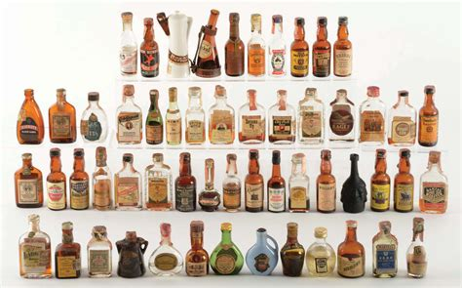

Chapter 7: The Art of Displaying and Preserving Miniatures
Displaying miniature bottles is an art in itself. Many collectors take pride in showcasing their collections in unique ways—some use glass-fronted cabinets, while others opt for wall-mounted shelves. Creative display solutions, such as custom-built shelves designed to fit specific bottle shapes or themed cabinets that reflect the type of spirit (e.g., whiskey, rum, or liqueurs), can add a personal touch and make a collection truly stand out. Some collectors even create diorama-style displays, incorporating small props to create scenes that enhance the visual appeal of their miniatures.
Maintaining these collections can be a challenge, as temperature, light, and humidity can all affect the quality of both the bottle and its contents. Proper storage is crucial for preserving the labels, glass, and the alcohol inside. Unlike full-sized bottles, the liquid in miniatures is more susceptible to evaporation, especially if the seal is not perfectly intact. This chapter will provide tips on how to maintain a collection to ensure it stands the test of time, such as ideal storage conditions, preventing evaporation, and maintaining label quality.

Chapter 8: Miniatures in the Modern World
Today, miniature bottles continue to serve various purposes. They are popular as party favors, wedding gifts, and holiday stocking stuffers. The convenience of miniatures has made them a staple for those wanting to sample high-end spirits without the hefty price tag of a full bottle. Many distilleries now offer tasting packs, which include a range of miniatures to provide consumers with a broader experience of their product offerings.
Furthermore, the rise of e-commerce has revolutionized the way collectors obtain new pieces for their collections. Websites like [Miniature Treasures]( https://www.miniaturetreasures.co.uk ) have embraced this digital shift, offering collectors a convenient way to browse and purchase miniatures from the comfort of their homes. Online marketplaces, auctions, and even social media groups have made it easier than ever to find rare and unique bottles from around the world. In addition, the emergence of NFTs has started to impact the traditional market for miniature bottles. Platforms like OpenSea and Rarible have made it possible for collectors to buy and sell digital representations of miniature bottles. Some notable digital collectibles have gained popularity, such as limited-edition NFT versions of iconic miniatures, which often come with perks like access to exclusive virtual tasting events or even the ability to redeem physical versions of the bottles. Digital representations of classic miniatures have attracted new types of collectors, particularly those interested in both spirits and blockchain technology. This trend is opening up new opportunities for collectors to showcase and trade their collections in the digital space.

Chapter 9: Display Ideas for Miniature Bottles
One of the joys of collecting miniatures is displaying them. Creative display ideas include custom-built shelves, glass cabinets with LED lighting, or even shadow boxes. A well-arranged display can turn a collection into a centerpiece for a room and an engaging conversation starter.
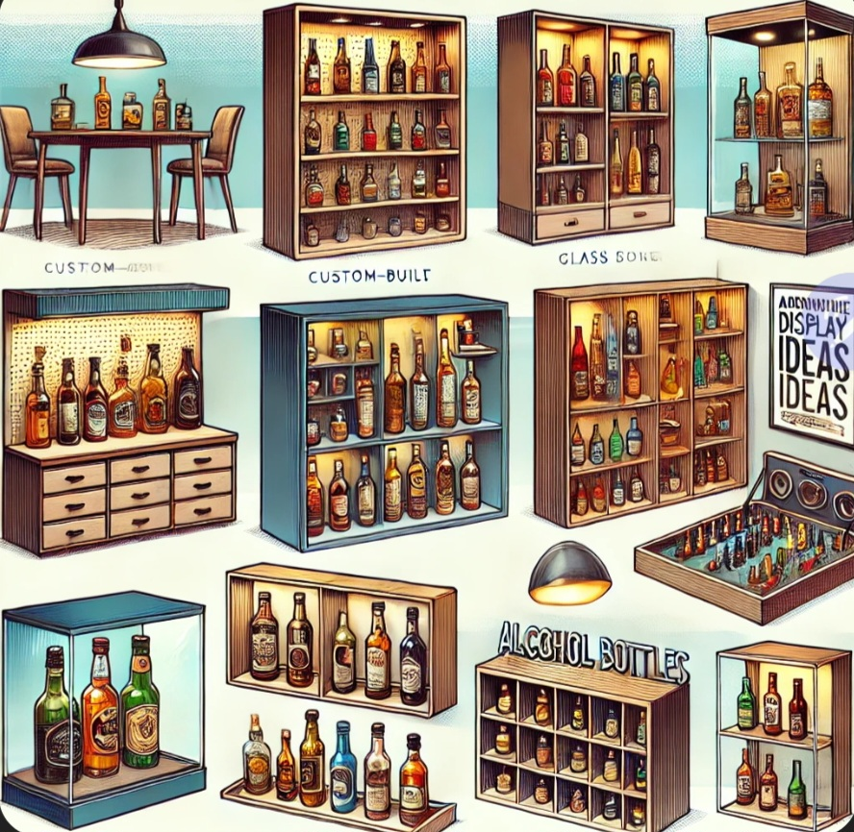

Chapter 10: Interesting Facts and Anecdotes
Did you know that some miniatures are now more valuable than their full-sized counterparts? Or that during the 1970s, airline companies produced exclusive miniature bottles that are now highly collectible? This chapter will share some interesting tidbits and anecdotes from the miniature alcohol bottle world that make collecting so intriguing.
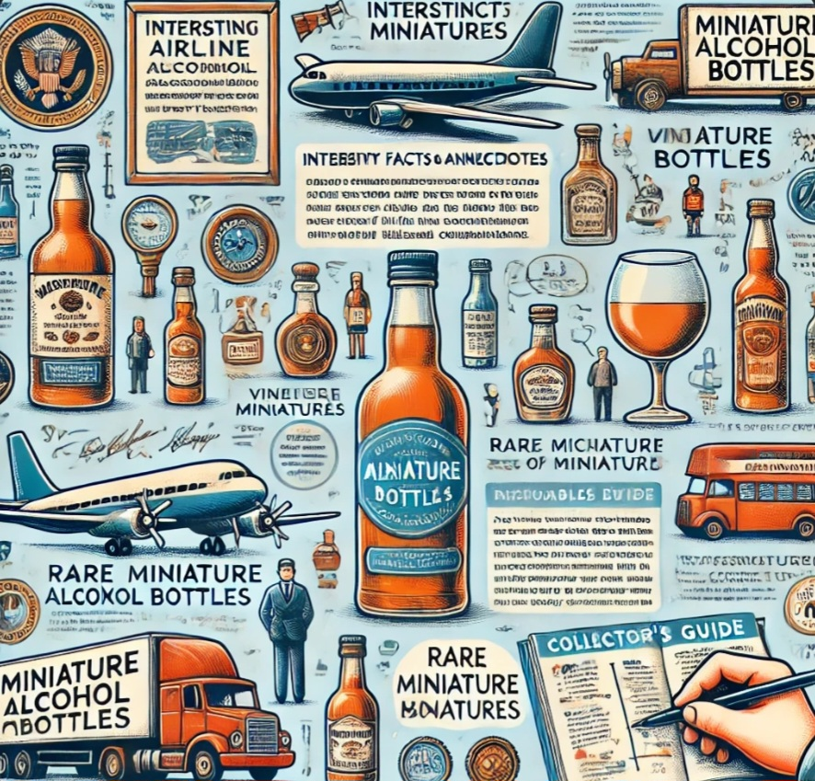

Chapter 11: Notable Collections Around the World
Some collectors have amassed thousands of miniature bottles, with notable collections being showcased in museums or private galleries. Highlighting famous collections, such as those found in Scotland's whisky museums or private displays in the U.S., can provide inspiration and show just how diverse the miniature bottle world can be.
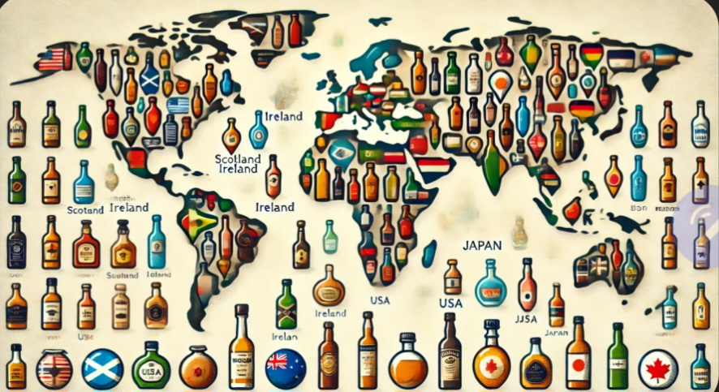

Conclusion
To reflect on your journey through the history of miniature alcohol bottles, consider how you might start or expand your own collection. What brands or themes interest you the most? Whether it's a focus on a particular era, rare finds, or simply the bottles that capture your imagination, collecting miniatures offers a unique way to connect with the stories behind these tiny treasures.
The world of miniature alcohol bottles is rich in history and culture, from their humble beginnings as promotional tools to their status as coveted collectibles today. Whether you are a seasoned collector or someone just getting started, these tiny treasures offer a fascinating glimpse into the world of spirits, marketing, and craftsmanship. Collecting miniatures is more than just acquiring bottles—it's about preserving history, celebrating creativity, and appreciating the stories contained within each tiny glass vessel.
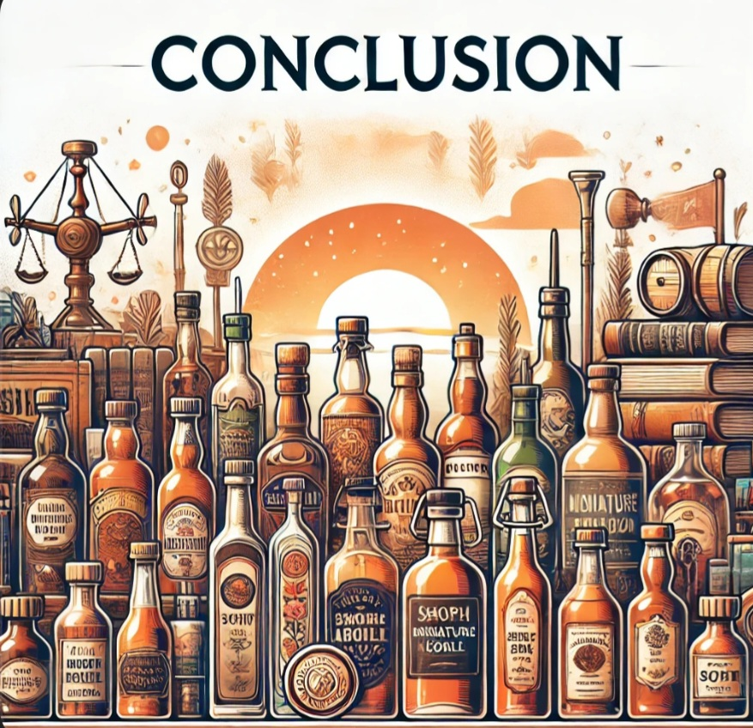

Afterword
If you are interested in starting your own collection, remember that every collection is unique. Whether you focus on a particular brand, region, or era, the world of miniature alcohol bottles has something to offer everyone. Happy collecting!

